CRIME RECORD MANAGEMENT SYSTEM USING CYBER SECURITY

DR.Mrs.S.Kavitha
Project Guide
Department of Computer Science Engineering
Vel Tech High Tech Dr. Rangarajan
Dr. Sakunthala Engineering College,
Chennai, Tamilnadu, India .

JEEVITHA .V VH12786 MONISHA. M VH12823 MONIKA PRASAD.N VH12821
Department of Computer science Department of Computer science Department of Computer science
and engineering and engineering and engineering
Veltech hightech Dr. Rangarajan Veltech hightech Dr.Rangarajan Veltech hightech Dr.Rangarajan
Dr .Sakunthala Dr.Sakunthala Dr.Sakunthala
Engineering college Engineering college Engineering college
Chennai India Chennai India Chennai India
jeevitha1406@gmail.com monisha.munirathinam@gmail.com monikaprasadn@gmail.com

ABSTRACT :
The Crime Record Management System Based on Cyber security is a safe web-based application that is intended to manage and keep crime-related records efficiently and securely. Conventional record keeping methods tend to make use of time-consuming manual processes, with susceptibility to human errors and without appropriate data security. This project seeks to automate the process of managing crime records through the deployment of sophisticated cyber security tools to guarantee confidentiality, integrity, and availability of sensitive data. The system enables registered users like police officers and administrators to register, update, and query crime information securely over encrypted channels. Technological elements like user authentication, role-based access control, and database encryption guarantee protection of data and block unauthorized access. The system not only facilitates the handling of crime data but also aids in quicker decision-making and analysis. By incorporating cyber security methods, the project guarantees a stable and secure platform for handling law and order information, leading to better crime investigation and handling of data efficiency
Keywords: Crime Record Management System, Cyber Security, Secure Web Application, Data Encryption, Role-Based Access Control, User Authentication, Database Security, Access Control Mechanisms, Encrypted Communication, Law Enforcement Information System, Data Integrity, Confidentiality and Availability.
INTRODUCTION:
In the modern era of cybernetic technology, crime record management is an essential aspect of law enforcement and public protection. Maintaining crime data through paper-based approaches is unproductive, time-consuming, and susceptible to loss or unauthorized use. In an effort to overcome these limitations, the Crime Record Management System Using Cyber security offers a computerized method for the storage, control, and retrieval of crime-related details in an efficient and safe way.This system permits authorized personnel to record crime information, suspects, victims, and case status using an easy-to-use interface. With the addition of cyber security aspects such as data encryption, authentication, and access control, the system permits confidential handling of sensitive data and against unauthorized users or cyber intrusions. It also enhances the reliability and availability of crime records so that law enforcement agencies can make informed decisions and boost investigative productivity. The proposed system minimizes physical effort to a large extent while maximizing data integrity and reliability. Real-time access, better coordination among departments, and a secure digital environment for effective crime management are facilitated by the system, which works towards building a smarter and safer society.
Crime Record Management System Through Cyber security is a secure online platform that was designed to help law enforcement agencies keep, access, and manage crime data efficiently. Crime records are usually kept manually in registers or spreadsheets in conventional systems, and therefore it is hard to update or pull out information instantly. This project has the goal of making the whole process automated through a centralized database which would maintain information on crimes, suspects, victims, and case status. By introducing cyber security concepts like authentication, 7 encryption, and secure data access, the system makes sure that confidential data is safe from unauthorized users.
Manual management of crime records results in a number of problems including redundancy of data, loss of files, unauthorized usage, and inconvenience in data retrieval. Additionally, the lack of due security protocols exposes sensitive data to cyber attacks and misuse. It is thus imperative that there is a need for a trustworthy and secure system capable of adequately managing crime records while protecting them from misuse through cyber security protocols.

LITERATURE SURVEY :
With the advancement of information technology, several researchers and developers have proposed automated systems to overcome these limitations .Early works in crime data management focused on database development to replace manual registers. These studies emphasized digital storage and easy retrieval of information, improving the efficiency of case handling and reporting. However, they often lacked strong security measures, making sensitive crime data vulnerable to unauthorized access. Researchers identified that maintaining data confidentiality, integrity, and availability was crucial for law enforcement databases.
To improve system security, some studies introduced access control mechanisms such as user authentication and authorization. These mechanisms ensured that only verified personnel could access or modify crime records. Role-based access control (RBAC) became a frequently recommended approach because it restricts system functionality based on user roles such as administrator, police officer, or investigator. This improved accountability and reduced the risk of data misuse.

As cyber threats evolved, later research integrated encryption techniques into crime management systems. Encryption protects data during storage and transmission, making it unintelligible to unauthorized entities. Studies have shown that combining encryption with secure communication protocols (e.g., HTTPS) enhances system resiliency against network-based attacks.

PROPOSED MODEL :
The system architecture consists of three main layers: the presentation layer, application layer, and database layer. The presentation layer provides a user-friendly interface that allows authorized users such as police officers and administrators to interact with the system. The application layer handles core functionalities including authentication, authorization, data validation, and encryption. The database layer securely stores crime records, user details, and system logs.
User access begins with a secure registration and login process. Authentication mechanisms verify user identity, while role-based access control (RBAC) ensures that users can access only the data and functionalities permitted by their role. This prevents unauthorized data modification and improves accountability within the system. To protect sensitive crime information, the proposed model integrates data encryption techniques for both data at rest and data in transit. Encrypted communication channels are used to prevent data interception during transmission. Input validation and secure session management further enhance system reliability and prevent common cyber attacks.
The system allows authorized users to add, update, view, and search crime records efficiently. Secure database operations ensure data integrity and prevent data loss or tampering. Additionally, activity logs are maintained to monitor user actions and support auditing. Overall, the proposed model offers a robust, secure, and scalable solution for managing crime records. By combining automation with cyber security practices, the system enhances data confidentiality, integrity, and availability, supporting effective law enforcement operations and faster decision-making.

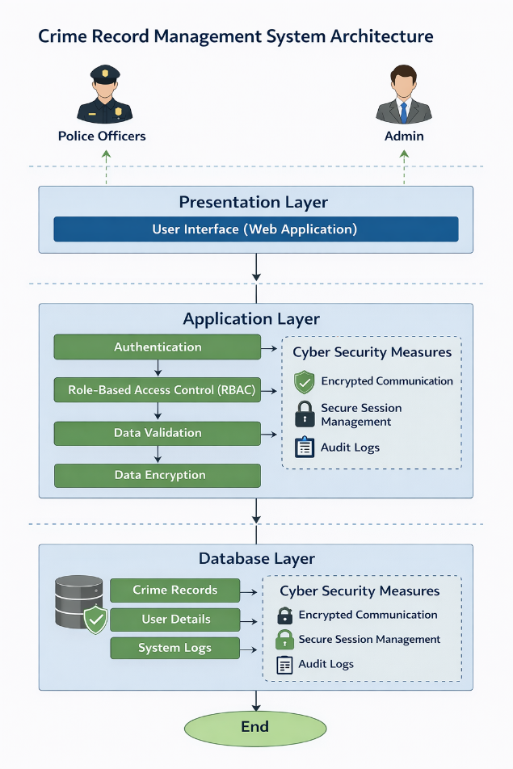
Figure 1.1 flow diagram of crms
1. Presentation Layer
The presentation layer acts as the interface between users and the system. It consists of a web-based user interface that allows users to log in, register, and perform authorized operations. This layer ensures ease of use while securely transmitting user requests to the application layer through encrypted communication channels.
2. Application Layer
The application layer contains the core logic of the system. It manages:
- Authentication to verify user identity
- Role-Based Access Control (RBAC) to restrict access based on user roles
- Data Validation to ensure accuracy and consistency of inputs
- Data Encryption to protect sensitive information
Additionally, this layer enforces key cyber security measures, including encrypted communication, secure session management, and audit logging. These mechanisms help prevent unauthorized access, data breaches, and session hijacking.
3. Database Layer
The database layer securely stores crime records, user details, and system logs. All sensitive data is stored in encrypted form to maintain confidentiality and integrity. Audit logs are maintained to track system activity and support monitoring and forensic analysis. Cyber security measures are integrated across both the application and database layers. Secure session handling, encrypted data storage, and activity logging ensure compliance with confidentiality, integrity, and availability (CIA) principles.
DATA FLOW DIAGRAM (DFD):
The Data Flow Diagram illustrates the information flow of the system.
THE LEVEL 0: Data Flow Diagram, also known as the Context Diagram, represents the Crime Record Management System (CRMS) as a single unified process and illustrates its interaction with external entities. This diagram provides a high-level overview of how users communicate with the system without exposing internal processing details.
In the proposed model, Administrators and Police Officers act as external entities that interact with the CRMS through a secure web interface. These users submit requests such as login authentication, crime record creation, updating existing records, searching crime details, and generating reports. All user inputs are securely transmitted to the system using encrypted communication channels.
Upon receiving user requests, the Crime Record Management System processes the data by performing authentication and access control verification. The system ensures that only authorized users are permitted to access or modify crime-related information. Based on the request type, the system either stores new data or retrieves existing records from the database.

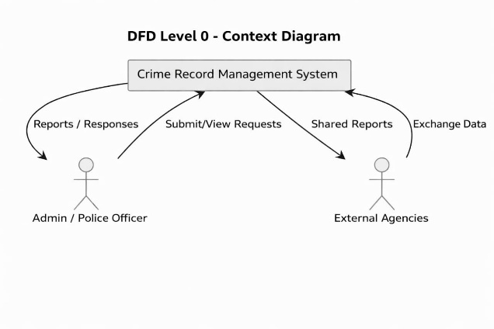
Figure 1.2 DFD level 0.

LEVEL 1 DFD: The Level 1 Data Flow Diagram presents a detailed breakdown of the internal processes of the Crime Record Management System. The Admin Login process validates user credentials through secure authentication mechanisms. Upon successful login, access is granted based on predefined roles and permissions. The Maintain Records process allows authorized administrators to insert new crime records, update existing case details, or remove outdated information. All inputs are validated before processing to ensure data accuracy. The View Reports module generates crime statistics and analytical reports based on stored data. These reports assist in decision-making and crime analysis. The database securely stores encrypted crime records, suspect details, and generated reports. Data encryption ensures confidentiality and integrity of sensitive information. Overall, the DFD illustrates the structured flow of data from the user interface through processing modules to the database grants access.
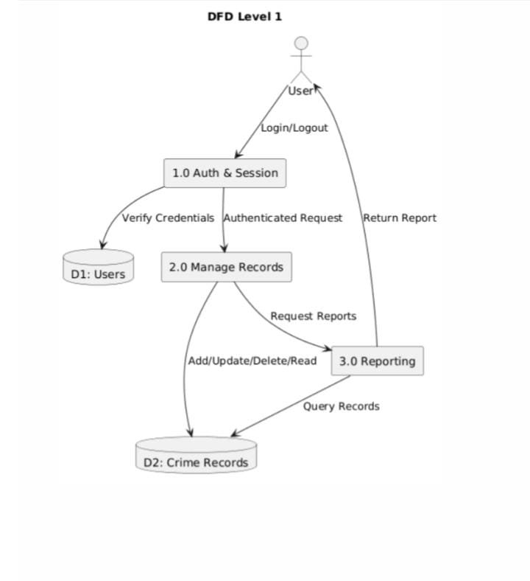
Figure 1.3 level -1
USE CASE DIAGRAM :
The Use Case Diagram illustrates the functional interactions between the Crime Record Management System and its external entities. The Administrator and Police Officer are the primary human actors who interact with the system through a secure interface. The Database System acts as a supporting actor responsible for data storage and retrieval. Both Administrator and Police Officer must perform Login and Logout operations to securely access the system. The Register Crime Case use case allows authorized users to enter new crime details into the system. The Update Crime Details use case enables modification of existing case information. Users can View Crime Records to retrieve and analyze stored crime data. The Generate Reports use case supports the creation of statistical and analytical crime reports. The Administrator is responsible for Manage User Access, including adding or modifying user roles and permissions. This diagram provides a clear overview of system functionality and role-based interactions.

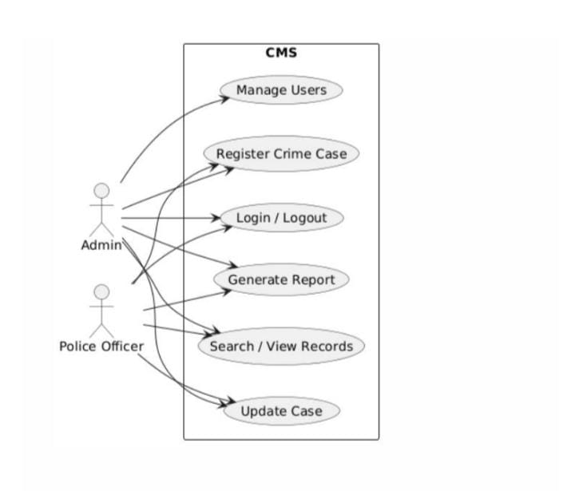
Figure 1.4 use case diagram
ENTITY RELATIONSHIP DIAGRAM :
The ER Diagram represents the logical structure of the Crime Record Management System by defining entities and their relationships. The User entity includes attributes such as User_ID, Name, Role, and Password, which identify and authenticate system users. The Crime Record entity stores core case information including Crime_ID, Crime_Type, Date, Location, and Description. The Suspect entity contains details such as Suspect_ID, Name, Age, and Address related to criminal cases. The Victim entity maintains victim-related information including Victim_ID, Name, Contact, and Case_ID . The Report entity records investigation details using attributes like Report_ID, Case_ID, and Investigation_Status. A relationship is established where a User manages Crime Records, indicating responsibility and access control. The Crime Record involves Suspect relationship captures associations between cases and suspects. The Crime Record generates Report relationship
represents the creation of investigation reports. These relationships ensure data consistency and traceability. Overall, the ER diagram provides a structured and organized database design for efficient crime data management.
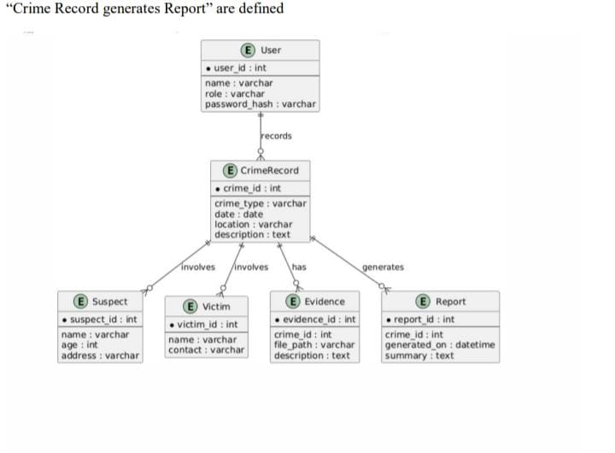
FIGURE 1.5 ER Diagram
CLASS DIAGRAM:
The Class Diagram represents the object-oriented structure of the Crime Record Management System and illustrates how system components are organized as classes. The User class is responsible for managing user authentication, authorization, and access control. It contains attributes such as user ID, role, and credentials, along with methods for login and logout operations. The Crime Record class handles the creation, modification, and retrieval of crime-related information. It includes attributes like crime ID, type, date, and location, and methods for adding or updating records. The Report class generates summary and analytical reports using stored crime data. This class supports data aggregation and presentation functionalities. The Database Connection class manages secure communication with the database. It ensures encrypted data transmission and reliable data storage operations. Each class contains well-defined attributes and methods that support system modularity and maintainability.
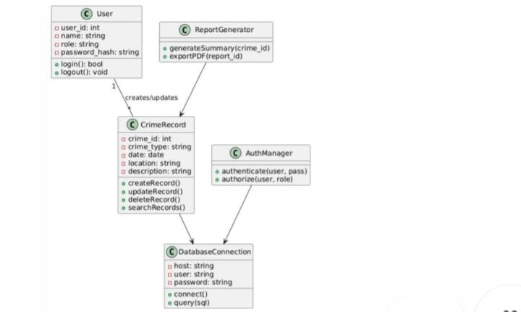
FIGURE 1.6 class diagram
RESULT AND CONCLUSION:
OUTPUT:
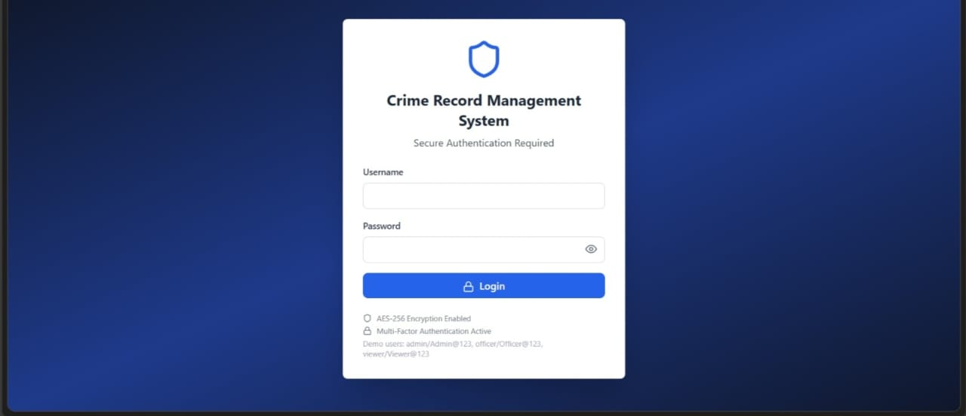
FIGURE 1.7 login page.
The login page is the entry point of the system where users authenticate themselves using valid credentials. It verifies the user’s identity through secure authentication mechanisms. Access is granted based on assigned roles and permissions. This ensures that only authorized users can access the system functionalities.

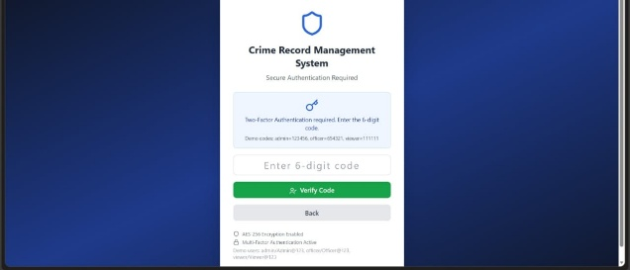
FIGURE 1.8 two factor authentication.

Two-Factor Authentication (2FA) is a security mechanism that requires users to verify their identity using two different authentication factors. It combines something the user knows, such as a password, with something the user has, like a one-time password (OTP). This method significantly reduces the risk of unauthorized access even if login credentials are compromised. In secure systems like Crime Record Management Systems, 2FA ensures enhanced protection of sensitive data.

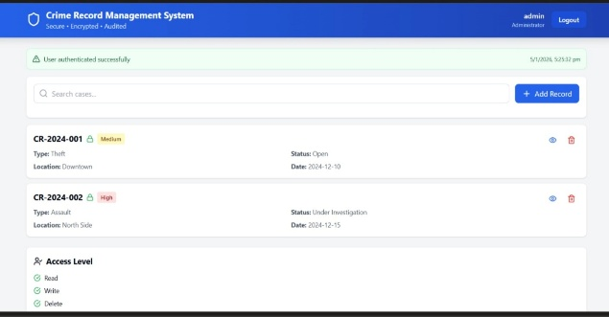
FIGURE 1.8 dashboard
The dashboard provides a centralized view of the system’s activities and key information. It displays summarized crime statistics and recent updates for quick access. Role-based dashboards ensure users see only relevant data and functions. This improves efficiency and supports faster decision-making.The dashboard offers quick navigation to core system features and reports. It enhances user productivity by presenting real-time insights in a clear and organized manner.
CONCLUSION:
The Crime Record Management System provides a secure and efficient solution for handling crime-related information in a digital environment. By replacing traditional manual record-keeping methods, the system significantly reduces human errors and improves data accuracy. The proposed system automates the process of storing, updating, and retrieving crime records, making information easily accessible to authorized personnel. Strong authentication and role-based access control ensure that only legitimate users can access sensitive data. The integration of encryption techniques protects data confidentiality and integrity during storage and transmission. The system supports faster investigation processes by enabling quick access to crime records and reports. Administrative functions such as user management and report generation enhance system control and accountability. The modular architecture improves system scalability and maintainability. Audit logging helps in monitoring activities and detecting unauthorized actions. Overall, the system enhances operational efficiency in law enforcement agencies. It ensures secure data management while supporting informed decision-making. The modular architecture of the system improves scalability and maintainability, allowing future enhancements without affecting existing functionality. The use of structured data models such as DFDs, ER diagrams, and class diagrams ensures clarity in system design and implementation. The system also supports efficient data retrieval and report generation, enabling faster decision-making and effective crime investigation.
Furthermore, the integration of cyber security principles strengthens the system against common threats such as unauthorized access, data tampering, and information leakage. Audit logging and secure database management provide additional layers of protection and support forensic analysis when required. The system contributes significantly to improving operational efficiency in law enforcement agencies.
Overall, the proposed Crime Record Management System offers a reliable, secure, and efficient approach to crime data management. It not only modernizes law enforcement record handling but also establishes a strong foundation for future technologies such as crime analytics, machine learning-based prediction, and cloud-based deployment. The system ultimately supports improved law and order management and enhances public safety.
REFERENCE:
1. Stallings, W. (2019). Cryptography and Network Security: Principles and Practice. Pearson Education.
2. Kurose, J. & Ross, K. (2021). Computer Networking: A Top-Down Approach. Pearson.
3. Pfleeger, C.P. & Pfleeger, S.L. (2015). Security in Computing. Prentice Hall.
4. OWASP Foundation (2024). “Top 10 Web Application Security Risks.” https://owasp.org
5. Government of India, National Crime Records Bureau (NCRB) Reports, 2023.
6. Tutorials Point. (2024). Crime Record Management System using Python and MySQL
7. Research papers and IEEE articles related to cybersecurity and secure database management systems.
8.OWASP Foundation, “OWASP Top 10 Web Application Security Risks,” Technical Report.
9.Laudon, K. C., and Laudon, J. P., Management Information Systems, Pearson Education.
10.Jain, A., and Gupta, R., “Secure Crime Data Management Using Web Technologies,” International Journal of Computer Applications

